NAME:UDAYA SANKAR C ROLLNO:231901058

|  |  |
| --- | --- |
| **Ex.No.: 2** | **DATA MANIPULATIONS** |

## Create the following tables with the given structure.

**EMPLOYEES TABLE**

|  |  |  |
| --- | --- | --- |
| **NAME** | **NULL?** | **TYPE** |
| Employee_id | Not null | Number(6) |
| First_Name |  | Varchar(20) |
| Last_Name | Not null | Varchar(25) |
| Email | Not null | Varchar(25) |
| Phone_Number |  | Varchar(20) |
| Hire_date | Not null | Date |
| Job_id | Not null | Varchar(10) |
| Salary |  | Number(8,2) |
| Commission_pct |  | Number(2,2) |
| Manager_id |  | Number(6) |
| Department_id |  | Number(4) |

CREATE TABLE Employees (

Employee_id NUMBER(6) NOT NULL,

First_Name VARCHAR2(20),

Last_Name VARCHAR2(25) NOT NULL,

Email VARCHAR2(25) NOT NULL,

Phone_Number VARCHAR2(20),

Hire_date DATE NOT NULL,

Job_id VARCHAR2(10) NOT NULL,

Salary NUMBER(8,2),

Commission_pct NUMBER(2,2),

Manager_id NUMBER(6),

Department_id NUMBER(4));

INSERT into Employees values(101, 'John', 'Doe', 'john.doe@example.com', '123-456-7890', '09-08-2000', 'IT_PROG', 60000.00, NULL, 100, 10);

INSERT into Employees values(102, 'Jane', 'Smith', 'jane.smith@example.com', '234-567-8901','09-04-2004', 'HR_MAN', 75000.00, 0.05, 101, 20);

INSERT into Employees values(103,'Mike','Johnson', 'mike.johnson@example.com','345-678-9012','05-23-2003','SA_REP', 4000.00,0.10, 102,80);

INSERT into Employees values(104, 'Emily', 'Austin', 'emily.austin@example.com', '456-789-0123', '03-30-

2001','FI_MGR', 3000.00, 0.01, 103, 40);

(a)Find out the employee id, names, salaries of all the employees

  SELECT  Employee_id,First_name,Last_Name,Salary from Employees;

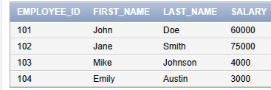

(b)List out the employees who works under manager 100

    SELECT Employee_id,First_name,Last_name FROM employees where Manager_id=100;



(c)Find the names of the employees who have a salary greater than or equal to 4800

       SELECT First_Name, Last_Name FROM Employees where salary>=4800;

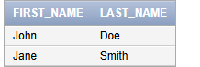

(d)List out the employees whose last name is =‘AUSTIN’

  SELECT Employee_id,First_Name,Last_Name FROM employees WHERE Last_Name='Austin';



(e)Find the names of the employees who works in departments 60,70 and 80

    SELECT First_Name,Last_Name FROM employees WHERE Department_id IN(60,70,80);



(f ) Display the unique Manager_Id.

       SELECT distinct Manager_id FROM employees;

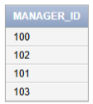

Create an Emp table with the following fields: (EmpNo, EmpName, Job,Basic, DA, HRA,PF, GrossPay, NetPay) (Calculate DA as 30% of Basic and HRA as 40% of Basic)

CREATE TABLE Emp

(

EmpNO NUMBER(4),

EmpName VARCHAR(25),

Job VARCHAR(25),

Basic NUMBER(10,2),

DA NUMBER(10,2) as (Basic*0.30),

HRA NUMBER(10,2) as (Basic*0.40),

PF NUMBER(10,2),

GrossPay NUMBER(10,2),

NetPay NUMBER(10,2)

);

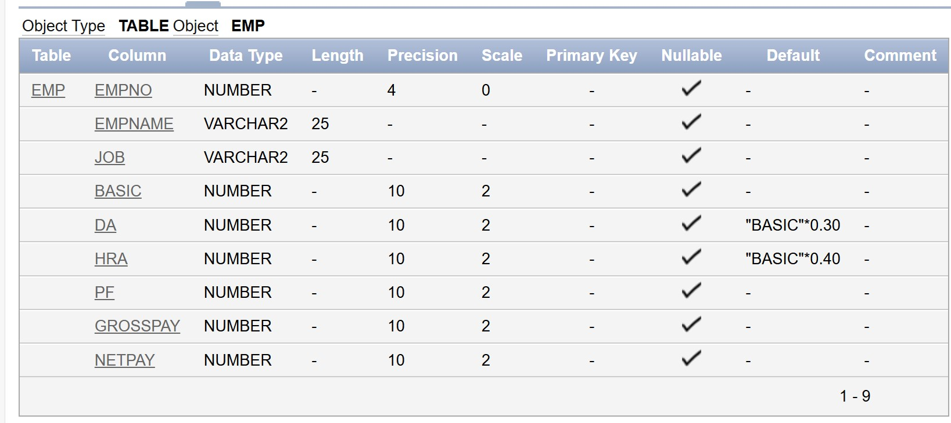

(a)Insert Five Records and calculate GrossPay and NetPay.

INSERT into Emp (EmpNo,EmpName,Job,Basic,PF) values (1,'john','manager',50000,5000);

INSERT into Emp(EmpNo,EmpName,Job,Basic,PF) values (2,'Alice','developer',40000,4000);

INSERT into Emp(EmpNo,EmpName,Job,Basic,PF) values (3,'Jane','designer',45000,4500);

INSERT into Emp(EmpNo,EmpName,Job,Basic,PF) values (4,'Smith','analyst',35000,3500);

INSERT into Emp(EmpNo,EmpName,Job,Basic,PF) values (5,'David','Tester',30000,3000);

UPDATE Emp set GrossPay=Basic+DA+HRA;

UPDATE Emp set NetPay=Basic -PF;

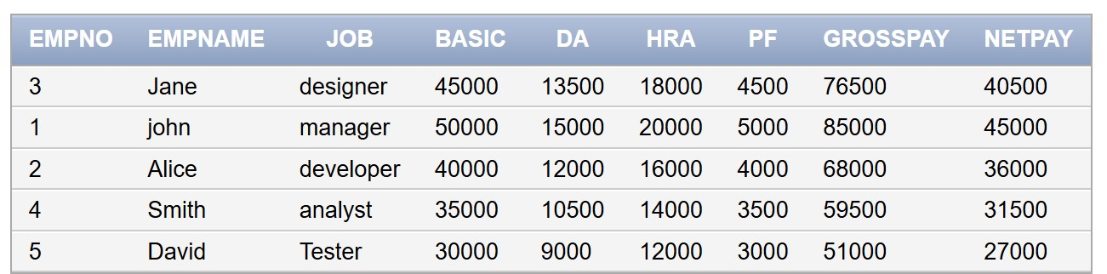

(b)Display the employees whose Basic is lowest in each department.

SELECT *from Emp where Basic=(select min(Basic) from emp);

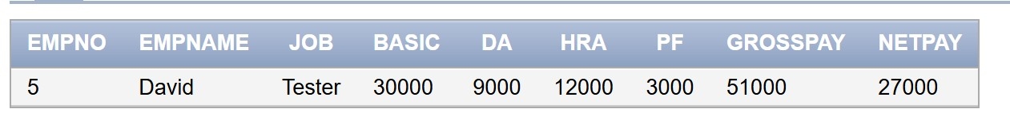

(c)If Net Pay is less than

SELECT *from Emp where NetPay=(select min(NetPay) from emp);

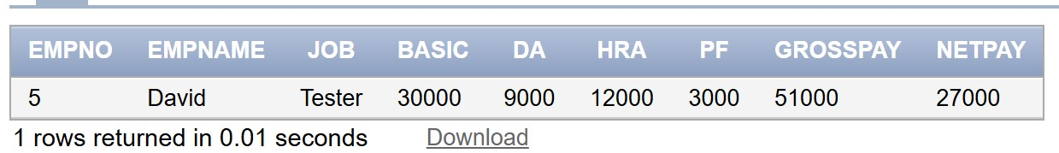

## DEPARTMENT TABLE

|  |  |  |
| --- | --- | --- |
| **NAME** | **NULL?** | **TYPE** |
| Dept_id | Not null | Number(6) |
| Dept_name | Not null | Varchar(20) |
| Manager_id |  | Number(6) |
| Location_id |  | Number(4) |

**JOB_GRADE TABLE**

|  |  |  |
| --- | --- | --- |
| **NAME** | **NULL?** | **TYPE** |
| Grade_level |  | Varchar(2) |
| Lowest_sal |  | Number |
| Highest_sal |  | Number |

## LOCATION TABLE

|  |  |  |
| --- | --- | --- |
| **NAME** | **NULL?** | **TYPE** |
| Location_id | Not null | Number(4) |
| St_addr |  | Varchar(40) |
| Postal_code |  | Varchar(12) |
| City | Not null | Varchar(30) |
| State_province |  | Varchar(25) |
| Country_id |  | Char(2) |

1.Create the DEPT table based on the DEPARTMENT following the table instance chart below. Confirm that the table is created.

|  |  |  |
| --- | --- | --- |
| **Column name** | ID | NAME |
| **Key Type** | Primary Key |  |
| **Nulls/Unique** | NOT NULL | NOT NULL |
| **FK table** | Department |  |
| **FK column** | Dept_id |  |
| **Data Type** | Number | Varchar2 |
| **Length** | 7 | 25 |

CREATE TABLE DEPT

(

ID NUMBER(7) PRIMARY KEY NOT NULL,

NAME VARCHAR2(25) NOT NULL,

Dept_id NUMBER(6) NOT NULL,

CONSTRAINT FK_Dept_DeptID FOREIGN KEY (Dept_id)

REFERENCES DEPARTMENT(Dept_id)

);

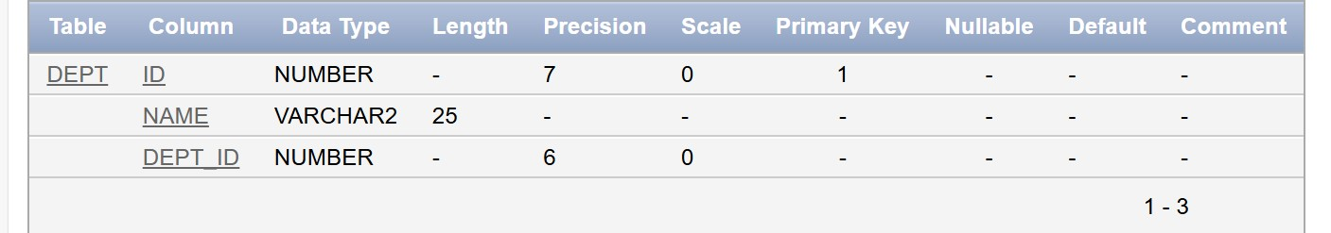

2.Create the EMP table based on the following instance chart. Confirm that the table is created.

|  |  |  |  |  |
| --- | --- | --- | --- | --- |
| **Column name** | ID | LAST_NAME | FIRST_NAME | DEPT_ID |
| **Key Type** | Primary Key |  |  |  |
| **Nulls/Unique** | NOT NULL | NOT NULL |  |  |
| **FK table** |  |  |  |  |
| **FK column** |  |  |  |  |
| **Data Type** | Number | Varchar2 | Varchar2 | Number |
| **Length** | 7 | 25 | 25 | 7 |

CREATE TABLE EMP (

ID NUMBER(7) PRIMARY KEY,

LAST_NAME VARCHAR2(25) NOT NULL,

FIRST_NAME VARCHAR2(25) NOT NULL,

DEPT_ID NUMBER(7)

);

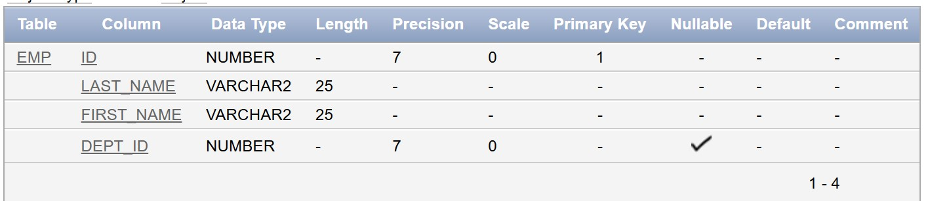

3.Modify the EMP table to allow for longer employee last names. Confirm the modification.(Hint: Increase the size to 50)

ALTER table Emp MODIFY Last_name varchar(50);

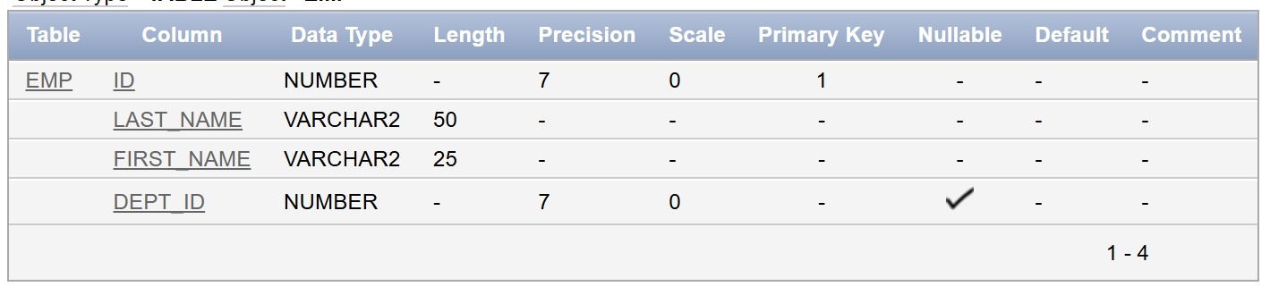

4.Create the EMPLOYEES2 table based on the structure of EMPLOYEES table. Include Only the Employee_id, First_name, Last_name, Salary and Dept_id coloumns. Name the columns Id, First_name, Last_name, salary and Dept_id respectively.

CREATE TABLE EMPLOYEES2 AS SELECT

Employee_id AS Id,

First_Name,

Last_Name,

Salary,

Department_id as dept_id

FROM EMPLOYEES;



5.Drop the EMP table.

DROP table Emp;

6.Rename the EMPLOYEES2 table as EMP.

ALTER table Employees2 rename to Emp;

7.Add a comment on DEPT and EMP tables. Confirm the modification by describing the table.

Comment on table DEPT is 'Table for storing dept details.'

Comment on table EMP is'Table for storing employee details.'

8.Drop the First_name column from the EMP table and confirm it.

ALTER table Emp Drop column First_Name;

